**Sawyer project- Understandable Robot Using ChatGPT**

**Group3-statistical analysis Results-scenario 1+2-Subjective measures:**

**1.Explanation Satisfaction Scale (average):**

**Shapiro-Wilk test for normality:**

**#For Adaptive Dialog (Adaptability = 1):**

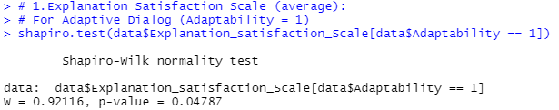

**Conclusion:** The p-value is less than 0.05, indicating that the data for **the Adaptive Dialog** condition **does not** **follow a normal distribution.**

**# For Non-Adaptive Dialog (Adaptability = 0):**

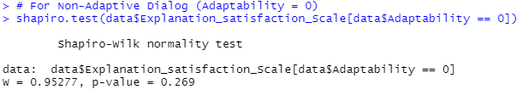

**Conclusion :**The p-value is greater than 0.05, suggesting that the data for the **Non-Adaptive Dialog** condition **follows a normal distribution**.

**Wilcoxon Signed-Rank Test for paired data for Explanation satisfaction Scale:**

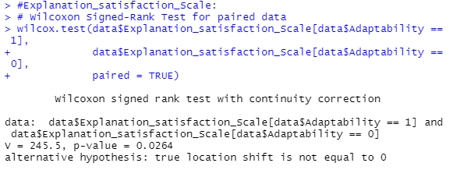

**Results:**

V = 245.5 : The test statistic (V) represents the sum of ranks for the positive differences between the paired conditions.

p-value = 0.0264: The p-value is less than 0.05, indicating that the difference in Explanation Satisfaction Scale between the two conditions is statistically significant.

Alternative hypothesis: The test suggests that there is a true location shift (difference) between the two conditions.

Calculating the t value:

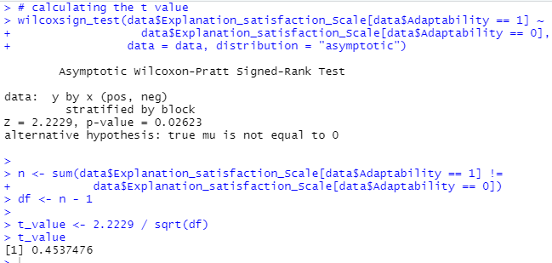

t value **≈** 0.454

**Conclusion:**

There is a statistically significant difference in Explanation Satisfaction Scale between Adaptive and Non-Adaptive Dialog conditions.

**Medians for Explanation satisfaction:**

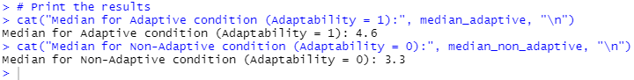 **Adaptive Condition (Adaptability = 1):** Median = **4.6**

**Non-Adaptive Condition (Adaptability = 0):** Median = **3.3**

The higher median value in the Adaptive condition suggests that participants reported higher Explanation Satisfaction when the dialog was adaptive (Adaptability = 1).

**2. Trust Scale (average):**

**Shapiro-Wilk test for normality:**

**For Adaptive Dialog (Adaptability = 1):**

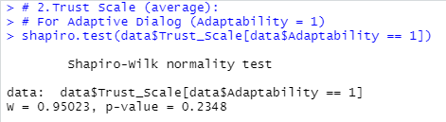

**Conclusion**: p-value>0.05 , The adaptive Dialog follows a normal distribution.

**For Non-Adaptive Dialog (Adaptability = 0):**

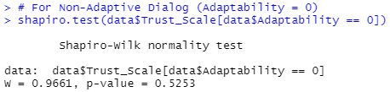

**Conclusion**: p-value>0.05 , The adaptive Dialog follows a normal distribution.

**# Mixed-effects model for Trust Scale:**

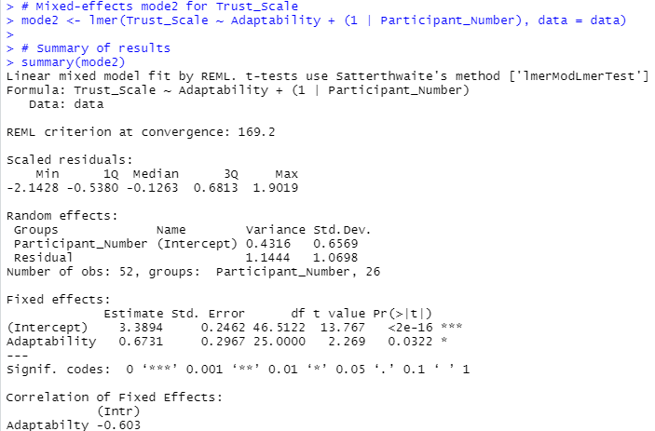

**Anova**:

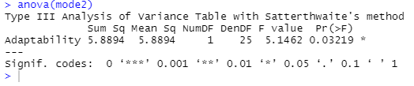

**Key results:**

1.The average trust score when Adaptability = 0 is approximately 3.39, Highly significant (**p < 0.001**).

2. On average, trust increases by 0.6731 when moving from non-adaptive to adaptive dialog. (Adaptability = 1)

**p-value**: 0.0322 , Since **p < 0.05**, this effect is **statistically significant**.

3. **Random Effects**: Variance in trust between participants (random intercept): 0.4316. Residual variance: 1.1444.

This indicates variability in trust scores attributable to differences among participants, but much larger variability remains unexplained.

**Conclusion:** The updated mixed-effects model indicates that **Adaptability** has a significant positive effect on trust. Participants exhibit higher trust scores when interacting with the adaptive dialog compared to the non-adaptive dialog. While individual variability (random effects) contributes to the trust scores, the adaptability of the system is a meaningful predictor of increased trust.

**3. Fluency of Interaction (average):**

**Shapiro-Wilk test for normality:**

**For Adaptive Dialog (Adaptability = 1):**

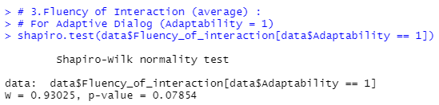 **Conclusion**: p-value>0.05 , The adaptive Dialog follows a normal distribution.

**For Non-Adaptive Dialog (Adaptability = 0):**

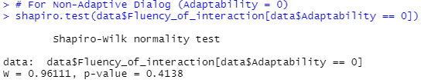

**Conclusion**: p-value>0.05 , The non adaptive Dialog follows a normal distribution.

**Mixed-effects mode3 for Fluency of interaction**:

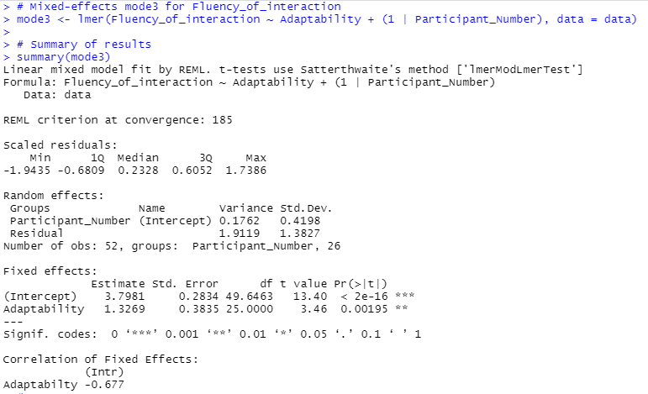

**Anova:**

**Results of the Mixed-Effects Model for Fluency of Interaction:**

* Adaptive dialog significantly increases Fluency of Interaction scores by 1.33 compared to Non-Adaptive dialog (p=0.00195).
* Variability between participants is low (random effect variance = 0.1762).
* ANOVA confirms a significant effect of Adaptability (F=11.97, p=0.00195).

**Conclusion:** Adaptive dialog improves interaction fluency significantly.